IBM

Configuring Apache Load Balancer

By
Nageswara R Desaraju
ndesaraj@in.ibm.com

Last Updated: March 2012

Version | Date issued | Author | Comments
1.0 | 03/01/2012 | Nageswara R Desaraju | Initial Version

Table of Contents

1. Introduction 4
1.1 Purpose: 4
1.2 Scope: 4
2. Overview and Configuration 4
2.1 What is a Load Balancer? 4
2.2 Configurations 5
3. References 10

1. Introduction

1.1 Purpose:

The purpose of this document is to configure an Apache HTTP server as a load balancer in a server cluster.

1.2 Scope:

Though the Apache Server has load balancing capabilities for HTTP, FTP and AJP13 protocols, this document only discusses the configurations for HTTP protocol.

2. Overview and Configuration

2.1 What is a Load Balancer?

A load balancer is a software / hardware appliance for distributing processing activities in cluster so that no single system is overwhelmed.

The method for load balancing depends on various parameters that would be defined in the load balancer. Some of the parameters are:
- By Traffic
- By Requests
- By Pending requests

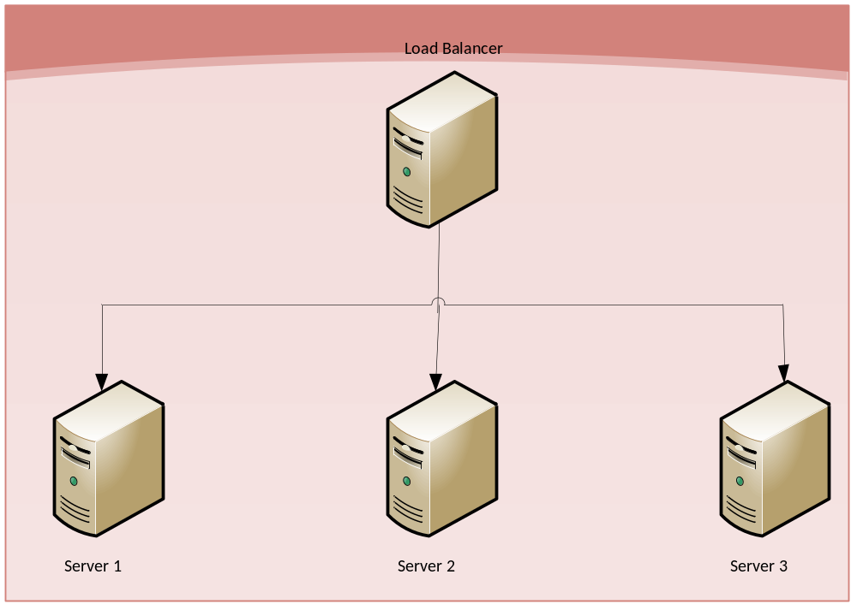

For many years load balancing has traditionally been associated with dedicated hardware. Typically these load balancers have been running on proprietary ASIC based hardware. As the power of standard computing hardware has evolved, other options have become a possibility.
It is no longer necessary to use dedicated specialized hardware for Load Balancing. With the ever increasing performance capacities of standard server hardware, it makes a lot of sense to take advantage of this trend rather than purchasing dedicated hardware. The Software Load Balancer solution delivers maximum flexibility to users, enabling them to take the powerful architecture of a hardware solution and build onto almost any server hardware platform of their choice.

2.2 Configurations

This section walks you through the various steps that need to be performed to configure an Apache server as an HTTP load balancer in a Windows (32) environment.

Step #1:

Download the Apache HTTP Server 2.2.22 from http://httpd.apache.org/. This version of the server provides various enhancements including the new mod_proxy_balancer module which provides load balancing services for mod_proxy. The new mod_proxy_ajp module adds support for the Apache JServ Protocol version 1.3 used by Apache Tomcat.

Step #2:

Install the Apache Server. The default location may be C:\Program Files\Apache Software Foundation\Apache2.2\

Step #3:

Navigate to the httpd.conf file generally located under C:\Program Files\Apache Software Foundation\Apache2.2\conf

Step #4:

Ensure that the below three modules are enabled in the httpd.conf file.

LoadModule proxy_module modules/mod_proxy.so
LoadModule proxy_balancer_module modules/mod_proxy_balancer.so
LoadModule proxy_http_module modules/mod_proxy_http.so

In order to get the ability of load balancing, mod_proxy and mod_proxy_balancer have to be present in the server.

Without enabling these modules, if we try to set the Proxy parameters and start the server, you might encounter an error like the one mentioned below:

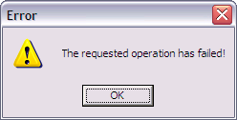

Step #5:

As per the Apache documentation, “Do not enable proxying until you have secured your server. Open proxy servers are dangerous both to your network and to the Internet at large.”

The server can be secured by configuring the below in the httpd.conf file:

<Proxy *>
Order Deny,Allow
Deny from all
Allow from 127.0.0.1
</Proxy>

Step #6:

This is the most important step in configuring your load balancer:

Apart from the server on which the Apache HTTP Server was installed, we need two more servers which would be our worker servers / nodes. For the sake of brevity, let us call them worker_server1.ibm.com and worker_server2.ibm.com

There are two ways in which the proxy balancer can be configured:

Option 1)

Add the below instruction in your httpd.conf file:

Include conf/extra/httpd-load-balancer.conf

This instruction points at an external configuration file to be included (relative path wrt to the Apache installation) where balancer configuration will be provided.

Now create the httpd-load-balancer.conf file in the /conf/extra folder and add the following lines:

<Proxy balancer://mycluster>
BalancerMember http://worker_server1.ibm.com:9900 loadfactor=1
BalancerMember http://worker_server2.ibm.com:9900 loadfactor=1
ProxySet lbmethod=bytraffic
</Proxy>
ProxyPass /EDI-X12 balancer://mycluster

Option 2)

Since the required balancer modules for the server (mod_proxy and mod_proxy_balancer) are already enabled, add the below lines directly to your httpd.conf file

<Proxy balancer://mycluster>
BalancerMember http://worker_server1.ibm.com:9900 loadfactor=1
BalancerMember http://worker_server2.ibm.com:9900 loadfactor=1
ProxySet lbmethod=bytraffic
</Proxy>
ProxyPass /EDI-X12 balancer://mycluster

With the above configuration, an instance of cluster is created (mycluster) with two members.

The /EDI-X12 context path is mapped to both the worker servers as shown below:
http:// worker_server1.ibm.com:9900/EDI-X12
http:// worker_server2.ibm.com:9900/EDI-X12

Step #7:

As mentioned earlier, there are three ways available on the Apache Server in which the load can be balanced among the servers in the cluster:

i) lbmethod=byrequests: The idea behind this scheduler is that we distribute the requests among the various workers to ensure that each gets their configured share of the number of requests.

With the below configuration, 20% of the requests would be forwarded to the first server and 80% of the requests would be forwarded to the second server.

<Proxy balancer://mycluster>
BalancerMember http://worker_server1.ibm.com:9900 loadfactor=2
BalancerMember http://worker_server2.ibm.com:9900 loadfactor=8
ProxySet lbmethod= byrequests
</Proxy>

ii) lbmethod=bytraffic: How much traffic, in bytes, we want this worker to handle. This is also a normalized value representing their "share" of the amount of work to be done, but instead of simply counting the number of requests, we take into account the amount of traffic this worker has seen.
In our above example, since we have assigned a loadfactor of 1 to both the worker server, each of the servers would process the same number of bytes.

iii) lbmethod=bybusyness: This scheduler keeps track of how many requests each worker is assigned at present. A new request is automatically assigned to the worker with the lowest number of active requests.
This algorithm is available in Apache HTTP Server 2.2.10 and later.

Stickyness: The Apache balancer supports stickyness of transactions. When a request is proxied to some back-end, then all following requests from the same user should be proxied to the same back-end.
Stickyness is not covered as part of this document.

Step #8:

This is the final step for the configuration of the load balancer.

You can easily configure an admin for the Apache Server to control the load balancer and to monitor the stats of the load balancer.

In order to get the ability of load balancer management, mod_status and mod_proxy_balancer have to be present in the server.

To enable load balancer management for browsers from the yourdomain.com domain add this code to your httpd.conf configuration file

<Location /balancer-manager>
SetHandler balancer-manager

Order Deny,Allow
Deny from all
Allow from .yourdomain.com
</Location>

The admin console can be accessed using the below URLs:

http://your.server.name/balancer-manager
http://your.server.name/balancer-manager?b=mycluster

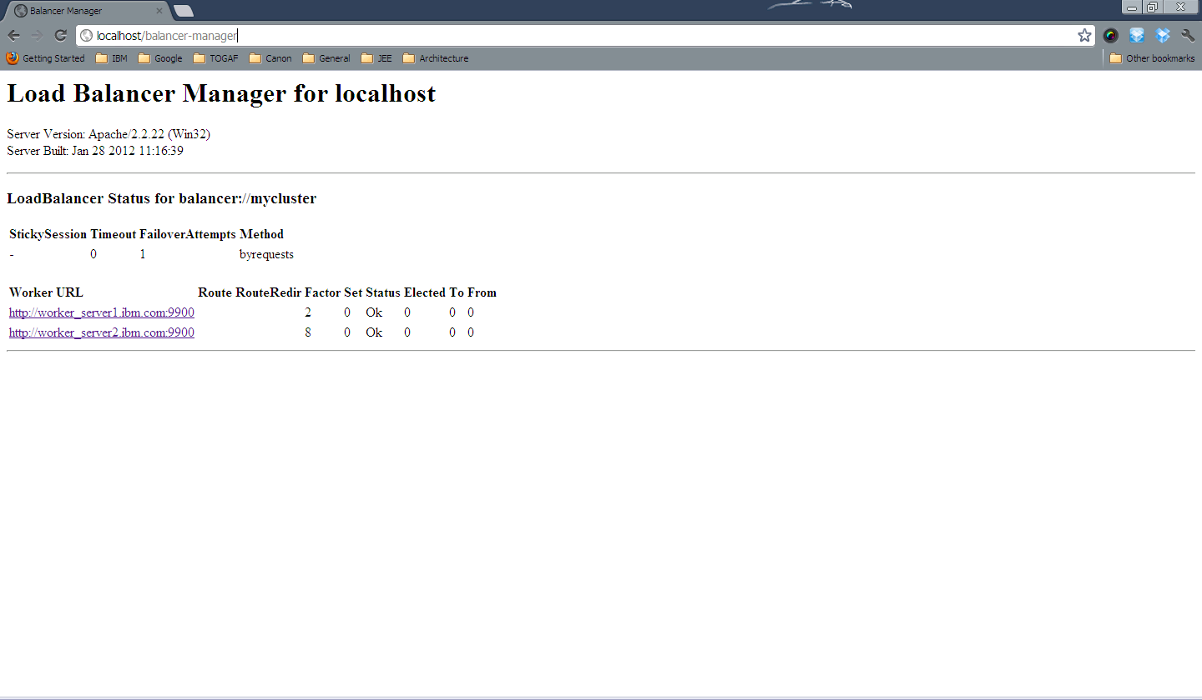

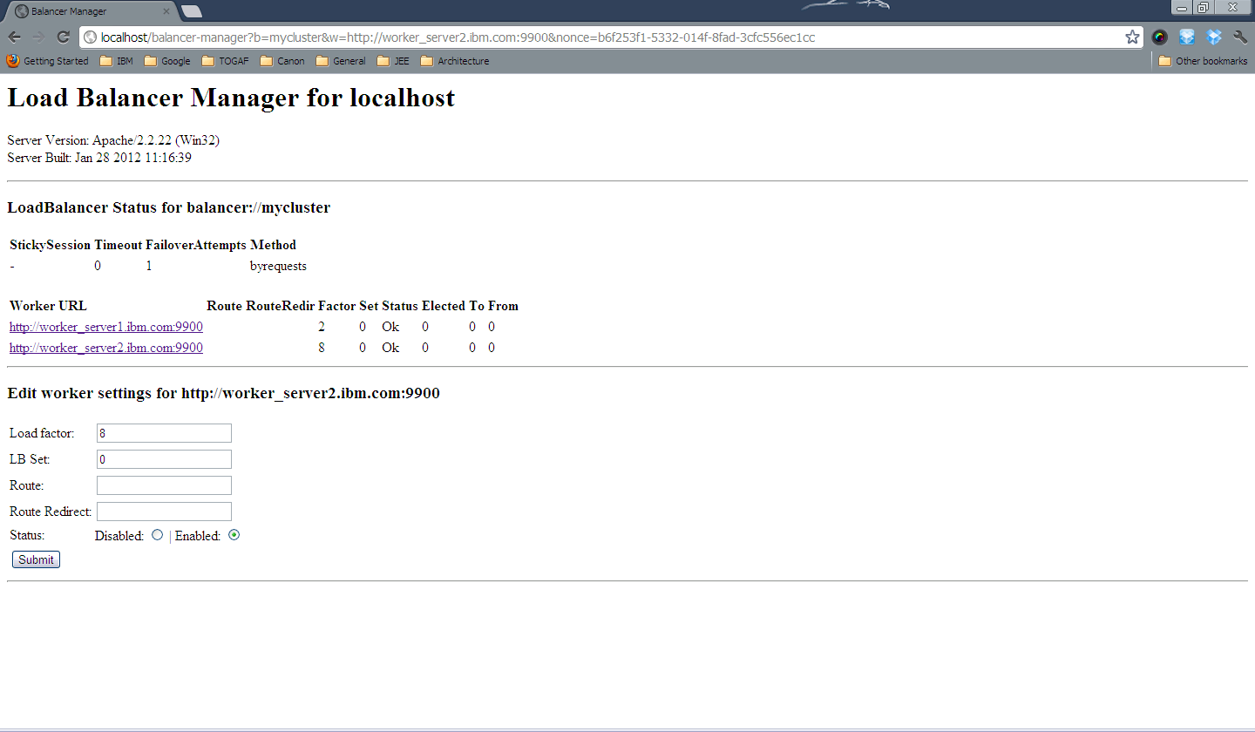

3. References

- http://httpd.apache.org/docs/2.2/mod/mod_proxy_balancer.html
- http://httpd.apache.org/docs/2.2/mod/mod_proxy.html
- http://blog.search-computing.net/2010/04/load-balancing-with-apache-a-tutorial-on-mod_proxy_balancer-installation-and-configuration/
- http://www.hardwareloadbalancer.com/software_load_balancer.htm

